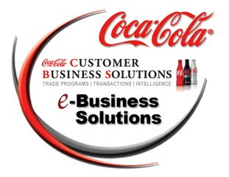

Document Pairings

If you send/receive one of these documents we would like the other as well.

810 invoice 820 payment
894 pre-delivery invoice 895 Delivery Return acknowledgment
857 ASN with price 895 Delivery Return acknowledgment

